Determining the objective

To start this project, the initial task involves examining the inquiry and gathering the essential data required to create the sales report, specifically for the sales team. Our approach was to carefully scrutinize and ensure that acceptance criteria were fulfilled at every stage.

Data Cleansing & Transformation (SQL)

To create the necessary data model for doing analysis the following tables were extracted using SQL.

Below are the SQL statements for cleansing and transforming necessary data.

One data source (sales budgets) was in Excel format and were connected in the data model in a later step of the process.

**DIM_Calendar: DIM_Customers**:

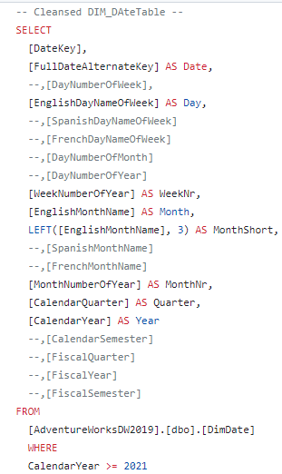 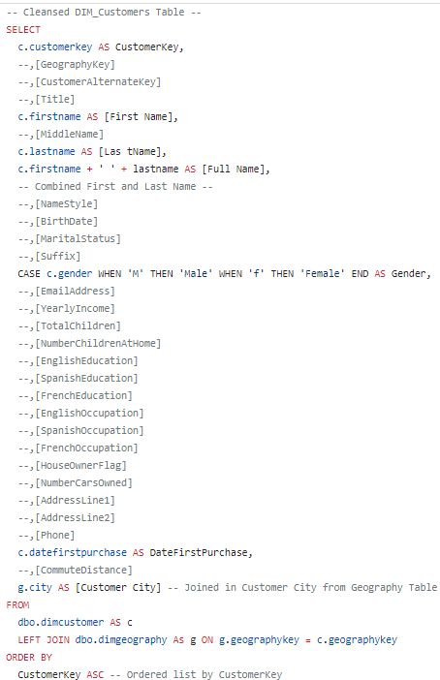

**DIM_Products: FACT_InternetSales:**

